**Student Projects Chapter 3 - Creating ER Diagrams for Student Projects**

Read the sample project steps for this chapter and apply the same techniques to the student project that you are developing.

For the project you have chosen, do the following:

* Step 3.1- Make a list of all entities and their associated attributes.

The entities appear to be:

Balance

Expenditures

Income

Member

Patrons

PlayListing

Program

Sponsors

Ticket

**Balance**

In identifying the attributes for an entity, we try to find data items that tell a single fact about an entity instance. For the income entity, we look for attributes whose value would tell us one piece of information about the income. Grouping the items from the data dictionary, the attributes that seem to describe the balance are:

*transactionDate, transactionAmount, transactionType*

**Expenditures**

Examining these more closely, we see that some of them form composite attributes, including:

expenditures, consisting of *auditoriumCost, contractorCost, equipmentCost, onSiteCosts, productionCost, totalExpenditures*

**Income**

Examining these more closely, we see that some of them form composite attributes, including:

Income , consisting of *duesPaid, onSiteIncome, otherIncome, sponsorIncome, ticketIncome, totalIncome*

**Member**

When we examine the data dictionary for items that describe the member in the program, we find the candidates for attributes are:

*duesAmount, duesPaid, memberAddress, memberAreaCode, memberCity, memberEmail, memberFirstName, memberLastName, memberPhoneNumber, memberState, memberZip, memberPosition*

**Patron**

When we examine the data dictionary for items that describe the patron in the program, we find the candidates for attributes are:

*patronAddress, patronAreaCode, patronCity, patronEmail, patronFirstName, patronLastName, patronPastPlays, patronPhoneNumber, patronState, patronZip*

**Playlisting**:

When we examine the data dictionary for items that describe the Playlisting in the program, we find the candidates for attributes are:

*playlistingAuthor, playlistingNumberofActs, playlistingTitle, playlistingType*

**Program:**

When we examine the data dictionary for items that describe the Program in the program, we find the candidates for attributes are:

*programCorporationsNames, programIndividualsNames, programMemberJob, programMemberRole, programMembersNames*

**Ticket**

When we examine the data dictionary for items that describe the Ticket in the program, we find the candidates for attributes are:

*customerNames, ticketsPlayDate, ticketsPlayNames, ticketsPlayTime, ticketsPrice, ticketsSeat, ticketsSeatNumbers*

* Step 3.2 - Make a list of relationships to be represented and any descriptive attributes for them.

Our entities are Balance, Expenditures, Income, Member, Patrons, PlayListing, Program, Sponsors, Ticket. Looking for relationships among them, we find the following.

**acts:** Member is related to Playlisting as the two connect a member’s role in a given playlisting

**transactionDate:** The date of the transaction.

**advertising:** A member of the theater group would reach out to patrons to attempt to sell tickets. Expenditures and Balance will be impacted by Advertising.

**buys:** Patron is related to a Ticket and Playlisting. A patron cannot have a ticket without the ticket being connected to a specific playlisting. Buys will have a direct impact on Income and Balance as well.

**calculate:** Balance is connected to, and is a function of, Income and Expenditures. We can calculate the balance on a transaction by transaction basis.

**paysDues:** Member is connected to Income as once the dues are paid, the income is changed.

**receiveTicket :** the play ticket connects the Patron to the Ticket in order to populate the ticket with the patron’s name

**populate :** program is connected to the Playlisting and Members. The members

are needed in order to populate the program with the correct cast, and the playlisting is needed to make sure the right play is detailed

**spends:** This relates Members to Expenditures, as any member of the theater group can make a purchase for the group which becomes a part of the group’s expenditures

**sponsors:** This relates the Sponsors to the the income, as any sponsor related sale increases the income for the group. Sponsors will also have a relationship to the Program.

* Step 3.3 - Draw an E-R diagram to represent the enterprise. Be sure to identify relationship participation and cardinality constraints, any weak entity sets, and role names, if needed. Use Figure S.3.1 in the sample project as a model for your diagram.

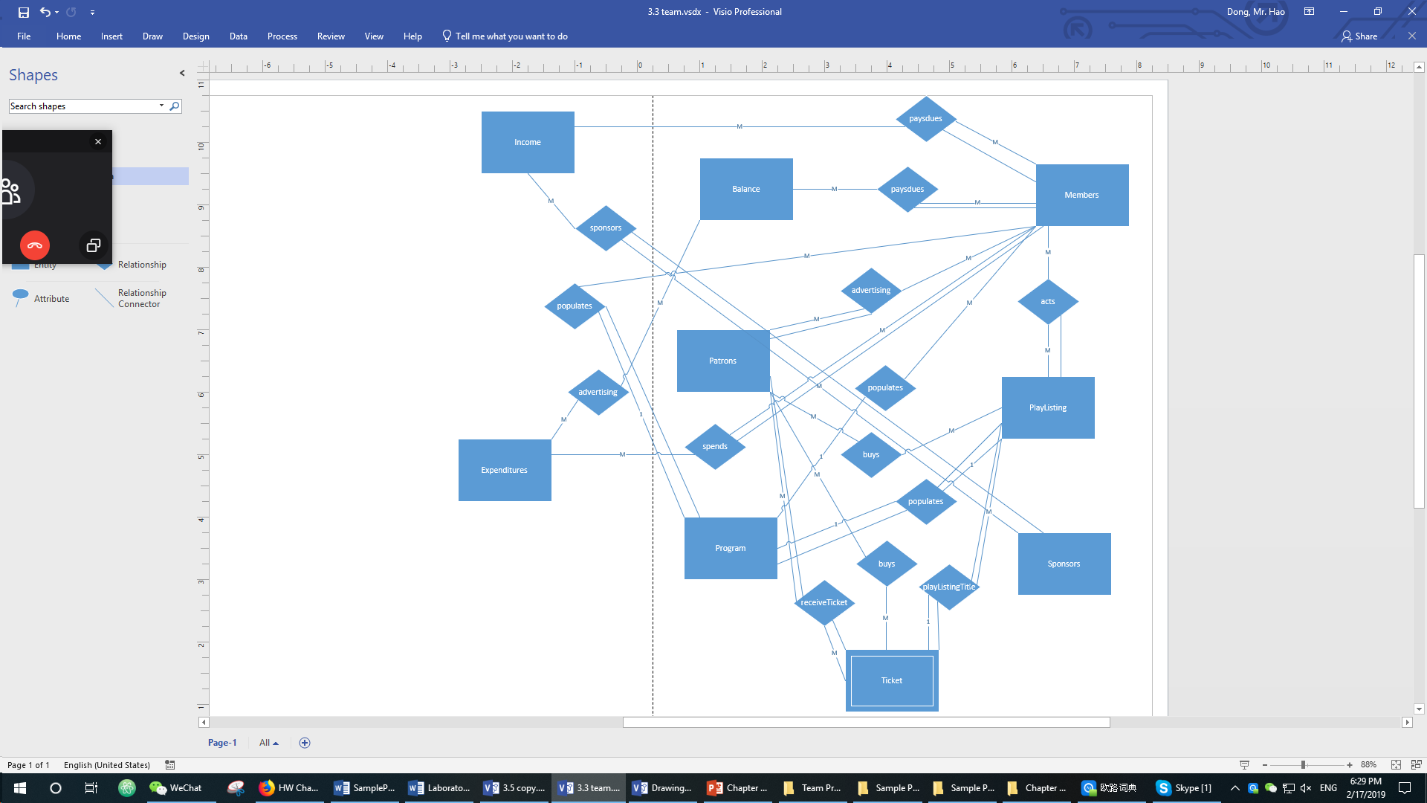

* Step 3.4 - Update the data dictionary and list of assumptions as needed.

|  |
| --- |
| **auditoriumCost:** The cost to rent the theater for the play |
| **contractorCost:** Any expenditures that come from outside contractors |
| **duesAmount:** The amount of money that each patron has paid for dues |
| **duesPaid:** A boolean variable that says whether or not a patron has paid their dues |
| **equipmentCost:** The cost of all the equipment |
| **member:** Amateur actors who produce and perform in productions. |
| **memberAddress:** The address of the member (not including zip code, town, and state) |
| **memberAreaCode:** The area code of the member’s phone number |
| **memberCity:** The city the member lives in |
| **memberEmail:** The email address of the member |
| **memberFirstName:** The first name of the member |
| **memberLastName:** The last name of the member |
| **memberPhoneNumber:** The remaining 7 digits of a member’s phone number |
| **memberState:** The state the member lives in |
| **memberZip:** The zip code of the area the member lives |
| **onSiteIncome:** The income that comes as a result of any sales at the play, including food, drinks, and merchandise |
| **otherCosts:** Any cost that occurred that is not included in a previous variable |
| **otherIncome:** Any income that is not included in one of the other income variables |
| **patronAddress:** The address of the patron (not including zip code, town, and state) |
| **patronAreaCode:** The area code of the patron’s phone number |
| **patronCity:** The city the patron lives in |
| **patronEmail:** The email address of the patron |
| **patronFirstName:** The first name of the patron |
| **patronLastName:** The last name of the patron |
| **patronPastPlays:** The List of the the productions the patron bought tickets for in the past. |
| **patronPhoneNumber:** The remaining 7 digits of a patron’s phone number |
| **patronState:** The state the patron lives in |
| **patronZip:** The zip code of the area the patron lives |
| **playlistingAuthor:** The author of the plays that could be produced by the company and will be played for the customers. |
| **playlistingNumberOfActs:** The number of acts during the whole play. |
| **playlistingTitle:** The title of the play |
| **playlistingType:** The type of the plays that could be produced by the company and will be played for the customers such as drama, comedy, musical, etc. |
| **position:** Represents the hierarchical position of an ExecutiveBoardMember. |
| **privileges:** specific privileges that a specific ExecutiveBoardMember would possess. |
| **productionCost:** the cost for the production rights. |
| **profitForTheYear:** The profit the group has which is income minus expenditures for the whole year. |
| **programCorporationsNames:** The names of the sponsors to support this program. |
| **programindividualsNames:** The names of the sponsors to support this program. |
| **programMemberJob:** The job of the members they have in this program. |
| **programMemberRole:** The role of the members they are playing in this program. |
| **programMembersNames:** The name of the members in this program. |
| **sponsorIncome:** The income that comes from sponsors. |
| **ticketIncome:** The income that comes as a direct result of ticket sales. |
| **ticketsPlayDate:** the date of the play. |
| **ticketsPlayNames:** The names of the play which will be shown on the tickets. |
| **ticketsPlayTime:** The play time of the plays which will be shown on the tickets. |
| **ticketsPrice:** The price of the tickets. |
| **ticketsSeat:** The seats where the customers will sit will be shown on the tickets. |
| **ticketsSeatNumbers:** The seat numbers which will be shown on the tickets. |
| **totalExpenditures:** The sum of all the cost variables. |
| **totalIncome:** The sum of all the income variables. |
| **transactionAmount:** The dollar amount of the transaction. |
| **transactionDate:** The date of the transaction. |
| **transactionType:** Type of transaction, i.e.: any attribute of “Income” or “Expenditure”. |

**Assumptions (New Additions are Highlighted)**

* A patron can have tickets to more than one play.
* Two patrons can have the same name.
* The theater group will handle the prices for plays.
* There is a limit to the number of seats one patron can buy.
* Each play performed has no copyright issues.
* Members of the group may have many roles to act in the same play.
* Payment for all sale from the customers and the way how the members of the play group pay the dues is made immediately. Payment can be accepted by credit, cash, or check.
* Every patron will receive a program.
* Each patron will be automatically signed up for the email distribution list which will send blast emails out regarding general announcements and advertising for other shows.
* The database will persist show history for each patron (keep a permanent record of all the shows that the patron bought tickets for).
* Real-time seat availability exists to avoid “concurrent” bookings of the same seat for any given show.
* A patron will be added to the database the first time they buy tickets for a play.
* A patron should be able to change their email, phone number, or address if a change is necessary.
* For the personal privacy, the treasurer has no right to share the personal information about the customers(including patrons) or sponsors or all the group members who need to pay the $50 per year.
* Lists of the group members who have potential chance to be elected as officers are evaluated each fall to determine whether they are good enough to work as officers. The rest of the group members will be distributed into either the group which people play roles or the group which people work behind the scenes.
* *Only the eboard members can make purchases with the group’s money*
* *There is a deadline for paying dues*
* *If dues are not paid, a member can be suspended*
* *There are understudies for the big positions in a play*
* *Different positions on the eboard have different privileges*
* Step 3.5 - Modify the E-R diagram and draw an EE-R diagram to represent the enterprise. Use generalization and union as necessary to express entity set relationships, adding appropriate constraint notation. Identify relationship participation and cardinality constraints using (min, max) notation. Use Figure S.3.2 in the sample project as a model for your diagram.

In our E-R diagram, we recognized that Member and Patron all have similar attributes. Since they are people, we created an entity set called Person with subsets of Member and Patron. Going a step further, we extended Member into StandardMember and ExecutiveBoardMember. While the Member entity set contains general attributes that describe both, StandardMember and ExecutiveBoardMember, there are unique attributes that distinguish the two entity sets. For example, an ExecutiveBoardMember IS-A Member with a particular position (President, Vice President, Treasurer, Secretary, etc…), and this type of Member has certain privileges that a StandardMember does not have. These privileges include actions related to Expenditures, Advertising, and interactions with Sponsors.

**Person (Attributes):** firstName, lastName, address, city, state, zip, areaCode, phoneNumber, email

**Member (Attributes): Subset of Person:** duesPayed, duesAmount, position

**Patron (Attributes) : Subset of Person:** pastPlays

**Executive Board Member: Subset of Member:** additional privileges - spends

